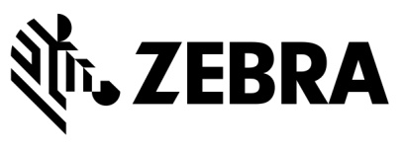

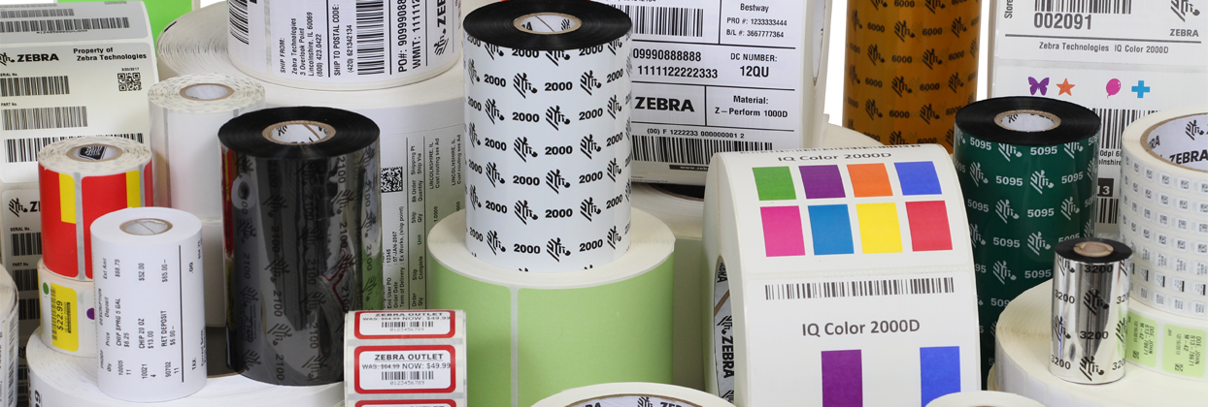
Broadline Technology Reseller Managed Print Services Promotion

NORTH AMERICA

DRIVING SUCCESS IN Supplies SALES
The Broadline Technology Reseller Managed Print Services Promotion (the “Promotion”) helps you generate reoccurring supplies revenue. This offer provides an additional discount of 6% on qualified sales of select Zebra ZipShip supplies when sold to customers through your Managed Print Services program.
This offer is available through December 31, 2019. Don’t miss this opportunity to drive revenue growth through the sale of printer labels, tags, receipt paper, ribbons and kits!

PROMOTION OVERVIEW
PROMOTION PERIOD | August 28, 2017 – December 31, 2019
ELIGIBILITY | All North America Zebra® PartnerConnect program Broadline Technology Resellers (“Participants”)
PRODUCT DISCOUNTS | An additional recommended upfront 6% discount off list price on qualified sales of the following Zebra ZipShip supplies (for desktop, mobile and kiosk printers) when sold to a customer participating in the reseller’s Managed Print Services program:  - Labels  - Tags  - Receipt paper  - Ribbons  - Kits  RFID supplies, wristbands and custom supplies are not eligible for the discount.  (Discount is recommended; participants should contact their Distributor for all pricing-related information. Final prices to Participants are determined by Distributors at their sole discretion.)
COMBINATION WITH OTHER DISCOUNTS | The Promotion cannot be combined with Price Concessions or product promotions, solution promotions or any other promotions for the same product.
PRODUCT SOURCING | All products included in the Promotion must be purchased from distribution.
PARTICIPATION PROCESS | Companies that want to participate in the Promotion must complete the program application form available from Partner Gateway (this document) and submit it to Zebra.
PARTICIPANT CRITERIA | - Participant must be enrolled in and in good standing in the PartnerConnect program as a Broadline Technology Reseller.  - Participant must offer a Managed Print Services program. For purposes of this Promotion, a Managed Print Services program means a program that sends customers automatic supplies replenishment or reminders of the need for such replenishment.  - Participant must:  - Promote their Managed Print Services offering externally on their web site, and participate in marketing opportunities and customer events  - Develop and maintain a quarterly business plan with its Zebra Channel Account Manager, Zebra representative or its distributor
MINIMUM ORDER QUANTITIES | There is no minimum order quantity.

FOR MORE INFORMATION
Channel Partner Questions
Participants should contact their Channel Account Manager or distributor for any questions about the program.
Distributor Information
Distributors should visit Partner Gateway and download the program’s VAD Terms and Processes to view distributor participation requirements.

FREQUENTLY ASKED QUESTIONS

Q: My company purchases product from a distributor. How can I determine my final percentage off, or my final price?
Contact your distributor for all pricing-related inquiries.

Q: Is there a minimum order quantity for this promotion?
No.

Q: Does the Promotion pricing incentive apply to orders that I have booked, but have not yet shipped?
Orders must be placed during the Promotion Period and must be shipped by the Distributor no later than 30 days after the conclusion of such period. Please note that product supply during the Promotion Period is subject to availability.

Q: Can I combine the Promotion with Price Concessions or other PartnerConnect promotion offerings?
The Promotion cannot be combined with Price Concessions or any other product promotions, solution promotions or other promotions. In addition, as a reminder, supplies are not eligible for the Deal Registration Program.

Q: Do I need to provide specific information at the time I place my order?
Yes. When you place your order with your distributor, you must provide the Promotion code along with your PartnerConnect Membership # to be eligible for the Promotion. You must also provide end-user name, country, and zip code information as well as any other sale-out information at the time of order.

You will be provided with the Promotion code upon approval of your participation in the Promotion.

Q: If I have specific questions about the Promotion, who should I contact?
Please contact your Channel Account Manager or distributor for any questions you may have about the Promotion.

PROMOTION PARTICIPATION APPLICATION
Please complete the form below, review the Terms and Conditions, sign where indicated and send to Gail Goebel (gail.goebel@zebra.com).
Gail Goebel (gail.goebel@zebra.com)

Channel Partner Membership #:
Channel Partner Name:
Channel Partner Contact Name:
Channel Partner Contact Phone:
Channel Partner Contact Email:
Channel Account Manager:
Date: |  | Current Partner Level:
Zebra Revenue from Supplies Sales Over Last Four Quarters: |  | % of Total Revenue from Supplies:
Managed Print Services Program Detail
- Provide the information requested below
AND
- Provide proof of thermal printing integration into Managed Print Services software solution (Proof may include marketing materials, web site content, technical documentation and/or demo of software solution and should be emailed with this application)
Name of Managed Print Services Software Solution Used to Facilitate Program:
Date of Integration of Thermal Printing Supplies into Managed Print Services Software Solution:
Date of Customer Launch for Thermal Printing Supplies Capability in Managed Print Services Software Solution:

PARTICIPANT TERMS
Promotion Period: August 28, 2017 – December 31, 2019
- Participation in the Promotion must be approved in writing by Zebra Technologies (referred to throughout this document as “Zebra”) prior to quoting to prospective customers Promotion pricing and at all times during the Promotion period.
- Zebra will maintain a list of the PartnerConnect Membership #s of all Promotion participants. This list will be provided to distributors as authorization for qualified Promotion transactions.
- Participant will be provided with a special Promotion code. Participant must notify the distributor, at the time of order, of Promotion eligibility by providing the Promotion code for each particular transaction.
- The Promotion is available for orders placed with a distributor during the Promotion Period and shipped by the Distributor no later than 30 days after the conclusion of such period. Product supply during the Promotion Period is subject to availability.
- Promotional discount structure and the incremental discount structure from distributors to Participants represent recommended discounts only. Distributors are always free to sell at the prices they choose.
- Participant must provide end-user name, country, and zip code information as well as any other sale-out information at the time of order with distributor to be eligible to receive the promotional pricing.
- The Promotion cannot be combined with any other product promotions, solution promotions or other promotions for the same product otherwise available to Participants. The Promotion cannot be combined with Price Concessions.
- Unless specifically stated otherwise in this Promotion document, the Promotion can be combined with any additional discounts that may be available to eligible Participants through a related PartnerConnect specialization.
- Zebra and its agents have the right to audit, validate, or verify any purchases/sales claimed and
serial numbers submitted.
- Zebra reserves the right to modify, withdraw, or cancel the Promotion (in whole or in part) at any time and/or in any geography for any reason or for no reason, without prior notice.
- Any requests that do not comply with the terms of the Promotion will be rejected. The Promotion is subject to all local laws and regulations.
- Based on the distributor sales out report validated by Zebra, if a Participant violates the conditions of the Promotion, Zebra or the distributor (as the case may be) have the right to bill back the difference between Participants’ standard discounts and the Promotion discount. Additionally, Zebra may terminate Participant from this Promotion and/or from the PartnerConnect program.
- Participants must provide quarterly sales out reporting to their CAMs. Failure to comply with the reporting requirements will result in removal from the Promotion.

DISPUTES
THIS PROMOTION IS GOVERNED BY THE LAWS OF THE STATE OF ILLINOIS, WITHOUT RESPECT TO CONFLICT OF LAW PRINCIPLES THEREOF.
As a condition of participating in the Promotion, Participant agrees that any and all disputes which cannot be resolved between the parties, and causes of action arising out of or connected with the Promotion, shall be resolved individually and Participant hereby irrevocably submits for itself and its property in any legal proceedings relating to the Promotion and enforcement of any judgments with respect and in connection thereto, to the exclusive general jurisdiction of the courts of competent jurisdiction located in Lake County, Illinois, U.S., and to the respective appellate courts thereof in connection with any appeal therefrom. Further, in any such dispute, under no circumstances will Participant be permitted to obtain awards for, and hereby waives all rights to claim punitive, incidental, consequential or other damages, including attorneys’ fees, other than the fair market value of the units purchased by Participant, and Participant further waives all rights to have damages multiplied or increased and to trial by jury. Under no circumstance will Zebra be liable for any Participant’s incidental, consequential, special, punitive, or exemplary damages of any kind, including lost profits, loss of business, or other economic damage arising out of or resulting from Zebra’s offering, conducting and/or terminating the Promotion or for any amount in excess of the market value of the Zebra product(s) purchased by the applicable Participant hereunder.
Please have an authorized representative of Participant sign below to indicate Participant understands and is in agreement with the Program rules and terms & conditions described above.
Terms and conditions reviewed and accepted by:
Name: __________________________________
Title: __________________________________
Signed: __________________________________
Date: __________________________________
on behalf of _____________________________________ (company name)
PartnerConnect Designation: __________________________________________
Proprietary and Confidential. ZEBRA and the stylized Zebra head are trademarks of Zebra Technologies Corp., registered in many jurisdictions worldwide. All other trademarks are the property of their respective owners. ©2019 Zebra Technologies Corp. and/or its affiliates. All rights reserved. 4-29-19

